ADVANCED DESIGN OPTIMISATION OF 6TH GENERATION FIGHTER JET AIRCRAFT

The domain of the Project:

AUTOCAD & SOLIDWORKS FOR MECHANICAL ENGINEERS

Team Mentors (and their designation):

Team Members:

Mr. Brahmendra.E
Ms. Julia James
Ms. Likitha H R
Mr. Vinayak V K

Period of the Project

April 2026 to May 2026

Declaration
The project titled “ADVANCED DESIGN OPTIMISATION OF 6TH GENERATION FIGHTER JET AIRCRAFT” has been mentored by Mr. Yallasiri Shanmukha RaviTeja, organised by SURE Trust, from December 2025 to May 2026, for the benefit of the educated unemployed rural youth for gaining hands-on experience in working on industry relevant projects that would take them closer to the prospective employer. I declare that to the best of my knowledge the members of the team mentioned below, have worked on it successfully and enhanced their practical knowledge in the domain.

Team Members:
Mr. Brahmendra E
Ms. Julia James
Ms. Likitha H R
Mr. Vinayak V K

Mentor’s Name Mr. Yallasiri Shanmuka RaviTeja
Designation—Company Name Junior Design Engineer- Sedin Engineering

Prof. Radhakumari
Executive Director & Founder
SURE Trust

Table of contents
- Executive summary
- Introduction
- Project Objectives
- Methodology & Results
- Social / Industry relevance of the project
- Learning & Reflection
- Future Scope & Conclusion

Executive Summary
- The project, titled “Advanced Design Optimisation of 6th Generation Fighter Jet Aircraft,” focuses on developing a conceptual fighter aircraft design that combines aerodynamic efficiency, stealth characteristics, advanced system integration, and innovative design features. The primary objectives were to create and optimize a 3D aircraft model using CAD, refine parameters such as wing sweep, fuselage blending, and air-intake placement, and propose a conceptual internal arrangement of major aircraft systems. The methodology followed a systematic sequence beginning with a literature review and identification of project objectives, followed by conceptual hand sketches, 2D drawings, 3D modeling, design calculations, and conclusion. Based on reference aircraft parameters and the literature study, the final concept incorporates a blended airframe, cranked-arrow wing configuration, DSI (Diverterless Supersonic Inlet), serrated trailing edges, canted vertical stabilizers, and twin engines. The developed aircraft has a conceptual length of 19.5 m, wing span of 14.1 m, height of 3.18 m, and a two-engine configuration. NACA 64A006 was selected for the wing and NACA 0008 for the vertical stabilizers. The conceptual internal layout includes radar and IRST, avionics, flight-control systems, an AI-integrated helmet, fuel tanks, electronic-warfare modules, an internal weapons bay, environmental and hydraulic systems, twin engines, and exhaust/nozzle sections.

- The research findings indicate that stealth-oriented airframe design can improve survivability and mission effectiveness, while advanced system integration and efficient airframe and propulsion configurations can contribute to overall mission performance. The literature review also highlighted the potential of serrated trailing-edge configurations to improve wake-flow characteristics and reduce aerodynamic noise without significantly affecting aerodynamic performance. The project successfully progressed from initial conceptual sketches to a complete 3D CAD model covering the aircraft from nose to nozzle, demonstrating the feasibility of integrating multiple modern aircraft design concepts into one conceptual platform. The final design therefore provides a foundation for further engineering development rather than representing a fully validated operational aircraft. Future work should focus on Computational Fluid Dynamics (CFD) analysis to evaluate lift, drag, pressure distribution, and flow characteristics. Further investigation of serrated trailing-edge dimensions, wavelengths, depths, and angles of attack is recommended, followed by design optimization based on analytical results. Development of a 3D prototype is also proposed for physical visualization, validation, and demonstration. These activities would help assess and improve the aircraft’s aerodynamic efficiency, stability, stealth characteristics, and overall performance.

Introduction
Background and Context
The development of modern fighter aircraft is increasingly focused on achieving a balance between aerodynamic efficiency, stealth, advanced technology, survivability, and mission effectiveness. Sixth-generation fighter concepts aim to overcome the limitations of existing platforms through advanced airframe configurations, improved stealth, autonomous and integrated systems, advanced avionics, and efficient propulsion. In this context, the project “Advanced Design Optimisation of 6th Generation Fighter Jet Aircraft” was undertaken to explore the conceptual development of a next-generation fighter aircraft using modern design principles and CAD-based modeling. The project builds upon findings from previous studies related to stealth design, aerodynamic performance, sensor integration, propulsion, and next-generation aircraft technologies.
Problem Statement and Goals
The project addresses the challenge of developing an aircraft configuration that can integrate stealth characteristics and aerodynamic efficiency while providing space for major aircraft systems and subsystems. The main goal was to create and optimize a conceptual 3D aircraft model by refining parameters such as wing sweep angle, fuselage blending, and air-intake placement. Another important goal was to develop a conceptual internal layout for arranging essential systems within the available airframe volume.
Scope and Limitations
The scope of the project covers literature study, conceptual design, hand sketches, 2D drawings, 3D CAD modeling, design calculations, and conceptual internal layout design. The final concept incorporates features such as a blended airframe, DSI intake, cranked-arrow wings, serrated trailing edges, canted vertical stabilizers, and twin engines. However, the project remains at the conceptual design and CAD modeling stage. Detailed CFD analysis, experimental validation, physical prototype development, and comprehensive aerodynamic testing were not included in the present work and are identified as areas for future development.
Innovation Component
The innovative aspect of the project is the integration of multiple advanced aircraft design features into a single conceptual platform. In particular, the combination of stealth-oriented shaping, DSI intake, serrated trailing edges, canted stabilizers, and an integrated internal systems layout provides a foundation for further optimization of aerodynamic and low-observable characteristics.

Project Objectives
- DESIGN OPTIMIZATION:- To create and optimize a 3D aircraft model using SOLIDWORKS by refining design parameters such as wing sweep angle, fuselage blending, and air intake placement to achieve aerodynamic efficiency and stealth characteristics.
The primary objective is to create and optimize a detailed 3D conceptual aircraft model using SOLIDWORKS, with emphasis on achieving a suitable balance between aerodynamic efficiency and stealth characteristics. The design process involves refining important geometric parameters such as wing sweep angle, fuselage blending, air-intake placement, wing configuration, and overall aircraft shaping. These parameters are considered to develop a streamlined airframe with reduced aerodynamic resistance and improved low-observable characteristics. The objective also includes converting the selected conceptual design into a precise 3D CAD model that represents the major external components of the proposed sixth-generation fighter aircraft.
- CONCEPTUAL INTERNAL LAYOUT DESIGN:- To propose the arrangement of major aircraft systems and subsystems within the available airframe volume.
The second objective is to develop a conceptual arrangement of the aircraft’s major systems and subsystems within the available airframe volume. The layout considers the placement of important components such as radar and IRST, avionics, flight-control computer, cockpit, fuel tanks, electronic-warfare modules, internal weapons bay, environmental and hydraulic systems, landing gear, twin engines, fuel-feed lines, and exhaust/nozzle sections. The arrangement is planned according to the different sections of the aircraft—front, wing, middle, and rear—to provide a logical representation of how essential systems could be integrated within the proposed airframe

Methodology and Results
Methods / Technology Used
The project “Advanced Design Optimisation of 6th Generation Fighter Jet Aircraft” followed a structured design methodology beginning with a detailed literature review. The literature review focused on sixth-generation fighter concepts, stealth technologies, aerodynamic configurations, propulsion systems, sensor integration, and serrated trailing-edge designs. The information obtained from previous studies was used to identify suitable design considerations and reference parameters for the proposed aircraft. The overall methodology followed the sequence: Literature Review → Objectives → Conceptual Hand Sketch → 2D Sketch → 3D Design → Design Calculations → Conclusion.
The first stage of design involved developing multiple conceptual hand sketches to visualize different aircraft configurations. From these concepts, a suitable configuration was selected and converted into accurate 2D drawings. Top, front, and side views were prepared using dimensions in meters, providing the basic geometric foundation for the subsequent 3D modeling process.
The next stage involved converting the selected 2D geometry into a complete 3D aircraft model. During this stage, major components such as the nose, fuselage, wings, air intake, vertical stabilizers, nozzle, and serrated trailing edges were developed and integrated. The design was refined with consideration of aerodynamic efficiency and stealth-oriented characteristics. The serrated trailing-edge configuration was incorporated based on literature findings indicating its potential to improve wake-flow characteristics and reduce aerodynamic noise without significantly affecting aerodynamic performance.

Tools / Software Used
Two major CAD software platforms were used in the project: AutoCAD and SOLIDWORKS. Each software played an important role at different stages of the aircraft design and development process.
AutoCAD was used primarily for the 2D drafting and technical drawing stage of the project. The aircraft geometry was represented through accurate top, front, and side views. These 2D drawings provided the dimensional reference required for developing the final three-dimensional aircraft model. The use of AutoCAD helped in understanding and establishing the aircraft's basic geometry, including the overall length, wing span, fuselage proportions, wing configuration, stabilizer dimensions, intake position, and other important features. Preparing the aircraft in multiple orthographic views also helped ensure that the geometry was consistent before moving into 3D modeling. The 2D design stage formed an important bridge between the initial conceptual hand sketches and the detailed 3D CAD model. It allowed the team to translate the conceptual design into a more precise engineering representation.
SOLIDWORKS was used for the 3D modeling and development of the complete conceptual aircraft. The project objective specifically involved creating and optimizing a 3D aircraft model using SOLIDWORKS, with attention to parameters such as wing sweep angle, fuselage blending, and air-intake placement. The 3D modeling stage involved developing individual aircraft components and integrating them into a single configuration. The final model included the nose, fuselage, wings, air intake, vertical stabilizers, serrated trailing edge, engines, and nozzle. Different views—including top, front, side, and isometric views—were used to demonstrate the completed model and its overall configuration. Using SOLIDWORKS enabled the team to visualize the aircraft in three dimensions and examine how individual components were positioned relative to the complete airframe. It also provided a suitable platform for representing the proposed design with greater detail than the initial 2D drawings.
Data Collection Approach
The project primarily used secondary data collected through literature review and reference aircraft parameters. Previous research relating to sixth-generation fighter aircraft, stealth, aerodynamic performance, propulsion, sensor integration, autonomous systems, and serrated trailing edges was reviewed. The literature provided information regarding parameters such as Mach number, altitude, stealth characteristics, maneuverability, sensor fusion, propulsion efficiency, wing geometry, and aerodynamic performance.
Reference parameters were then used to establish the conceptual dimensions and configuration of the proposed aircraft. The final design calculations established major parameters such as 19.5 m overall length, 14.1 m wing span, 3.18 m height, two engines, one crew member, NACA 64A006 wing airfoil, and NACA 0008 vertical stabilizer airfoil. Additional parameters included wing sweep angles, stabilizer cant angle, nozzle diameter, intake dimensions, and serrated trailing-edge dimensions.
Project Architecture
The project architecture can be represented as a sequential aircraft conceptual-design workflow:
Literature Review
↓
Project Objectives
↓
Conceptual Hand Sketches
↓
2D AutoCAD Design
↓
3D SOLIDWORKS Modeling
↓
Design Calculations
↓
Conceptual Internal Layout
↓
Final Aircraft Configuration
↓
Conclusion & Future Scope
The architecture begins with research and progresses toward practical CAD implementation. The hand-sketch stage provides initial design concepts, while AutoCAD converts the selected concept into accurate 2D geometry. SOLIDWORKS then transforms this geometry into a complete 3D aircraft configuration. Design calculations are used to establish and document the major aircraft parameters. Finally, the conceptual internal layout demonstrates how major systems and subsystems can be positioned within the airframe.
The internal architecture is divided into front, wing, middle, and rear sections. The front section contains conceptual elements such as radar and IRST, avionics, flight-control computer, cockpit, AI-integrated helmet, ejection seat, and front landing gear. The wings accommodate fuel tanks, radar warning receiver, electronic-warfare modules, and DSI inlets. The middle section includes the internal weapons bay, fuel tanks, environmental control system, hydraulic systems, and main landing gear. The rear section contains twin engines, engine air ducts, fuel-feed lines, flares, and exhaust/nozzle components.
Final Project Working Screenshots and Supporting Explanation
The final project presentation contains multiple screenshots demonstrating the progression and completion of the aircraft model. The 2D AutoCAD drawings include top, front, and side views, which establish the aircraft's basic dimensions and geometry. These drawings provide a clear engineering representation of the aircraft before 3D development.
The SOLIDWORKS 3D model is presented through top, front, side, and isometric views. The top view identifies the major components, including the nose, fuselage, wing, intake, vertical stabilizer, nozzle, and serrated trailing edge. The front and side views provide additional visualization of the aircraft's proportions and configuration, while the isometric view demonstrates the overall integration of the components into a single 3D aircraft model.
The final model represents a complete conceptual aircraft from nose to nozzle, incorporating a blended airframe, DSI intake, cranked-arrow wing, serrated trailing edge, and canted vertical stabilizers. The project successfully demonstrates how an aircraft concept can progress from research and hand sketches through AutoCAD 2D drafting to SOLIDWORKS 3D modeling.
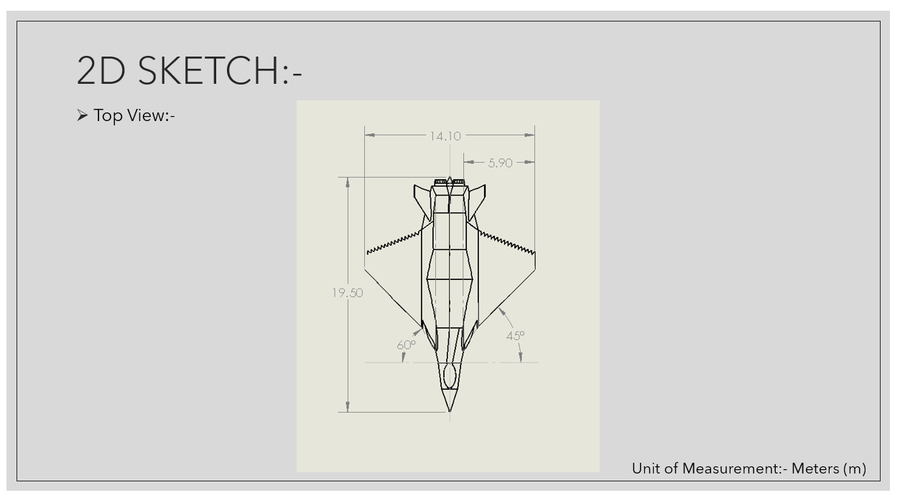
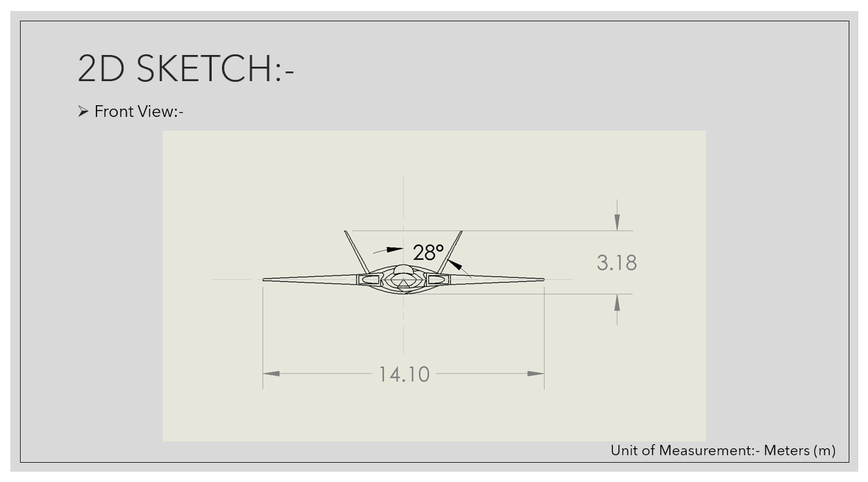

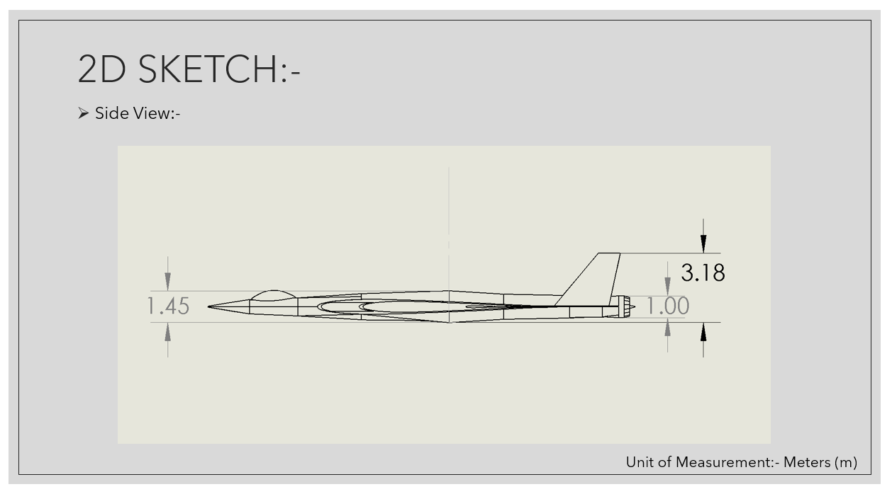

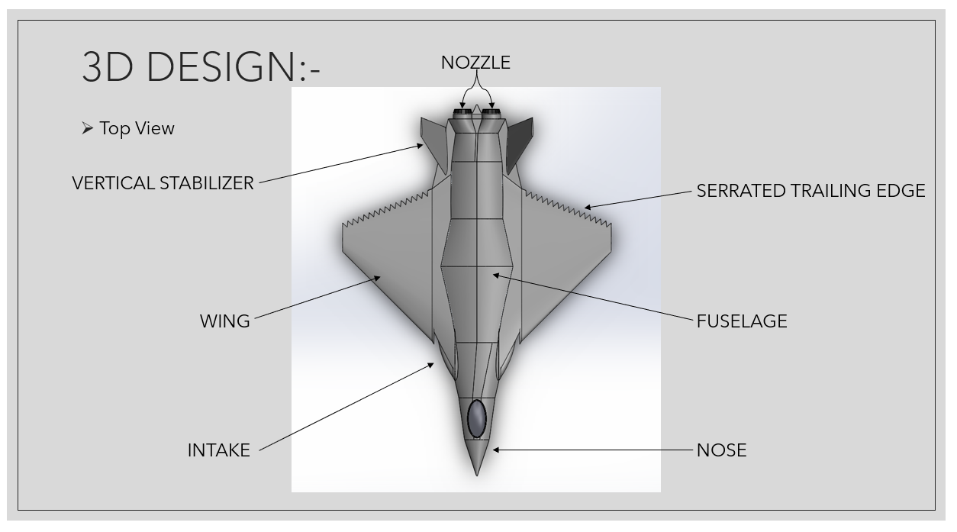

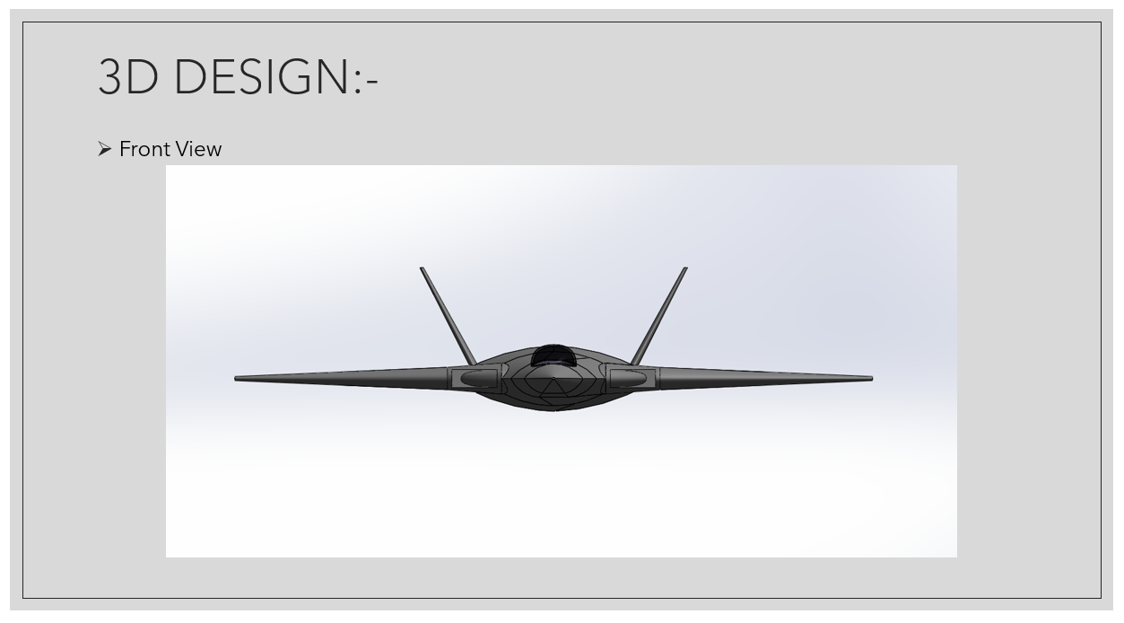

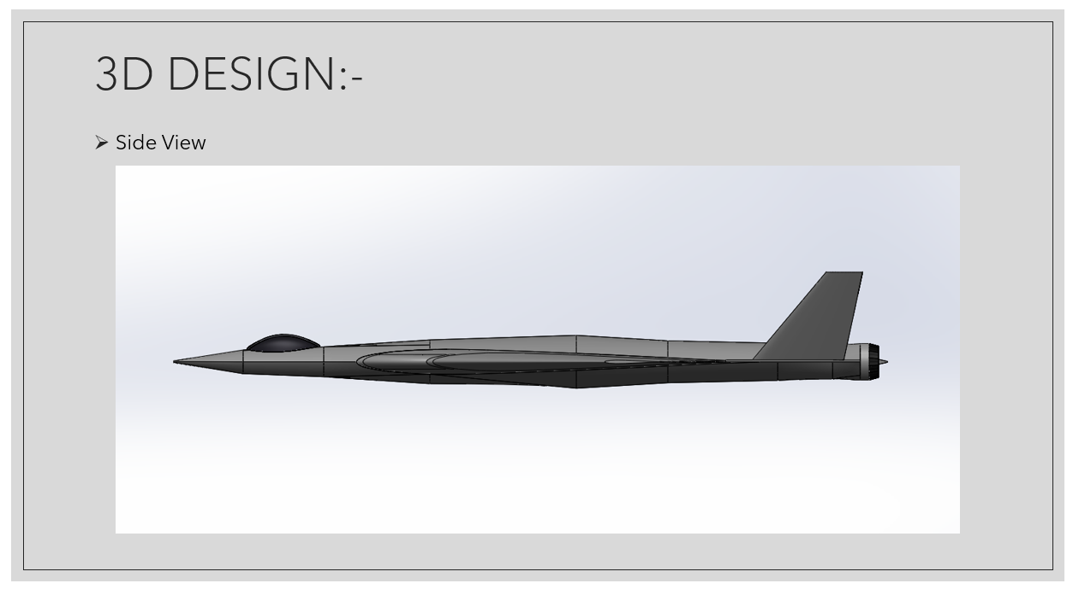

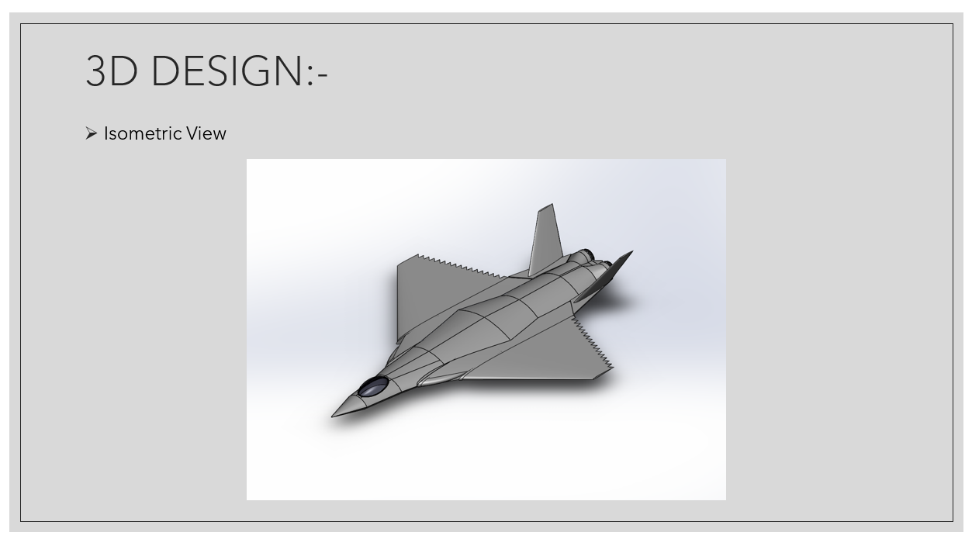

Results
The major result of the project is the successful development of a complete conceptual 3D fighter aircraft model. The design demonstrates the integration of multiple modern aircraft design features into one platform. The project also established a conceptual internal layout and a set of design parameters that can be used as a foundation for further analysis.
However, the present project is primarily a conceptual design and CAD modeling study. Detailed aerodynamic validation through CFD and physical prototype testing were not performed. Therefore, the aerodynamic and stealth characteristics represented in the design require further validation.
Project GitHub Link
GitHub Link:
https://github.com/brahmendra23/ADVANCED-DESIGN-OPTIMISATION-OF-6TH-GENERATION-FIGHTER-JET-AIRCRAFT

Learning and Reflection
Team Members’ New Learnings
Brahmendra E: Gained practical knowledge in aircraft conceptual design, research analysis, and SOLIDWORKS 3D modeling. Learned how to develop an aircraft configuration from the nose to nozzle and understand the integration of major components. Also improved teamwork, time management, and coordination skills.
Julia James: Developed practical skills in 3D CAD modeling and vertical stabilizer design. Gained a better understanding of aircraft component integration and the importance of accuracy in developing individual parts. Also learned effective communication and coordination while working as part of a team.
Likitha H R: Gained experience in conceptual aircraft design, hand-sketch development, and 3D modeling of the wing section. Learned how design concepts are transformed into finalized CAD components. The project also improved her problem-solving, teamwork, and task-management abilities.
Vinayak V K: Developed practical knowledge of 3D CAD modeling and vertical stabilizer design, along with an understanding of how individual components contribute to the overall aircraft configuration. Improved collaboration, communication, and responsibility while completing assigned project tasks.
Overall Team Experience
The project provided the team with valuable hands-on experience in aerospace conceptual design and CAD-based modeling. Working from literature review and initial sketches to 2D drawings, calculations, and a complete 3D aircraft model helped the team understand the overall design-development process. Each member gained experience in handling individual responsibilities while coordinating with other team members to achieve a common objective. The project also strengthened skills in teamwork, communication, time management, problem-solving, design thinking, and technical decision-making. Overall, the experience helped the team connect theoretical concepts with practical design work and provided a strong foundation for further learning in aircraft design and engineering.

Conclusion and Future Scope
Conclusion
The project successfully achieved its primary objectives of developing a conceptual 3D model of a 6th-generation fighter aircraft with a focus on design optimization, stealth characteristics, and aerodynamic considerations. The work progressed systematically through literature review, conceptual hand sketches, 2D drawings, design calculations, and 3D CAD modeling. The final aircraft configuration incorporates important features such as a blended airframe, cranked-arrow wing, DSI intake, serrated trailing edge, canted vertical stabilizers, and twin-engine arrangement. A conceptual internal layout was also developed to represent the placement of major aircraft systems and subsystems within the available airframe volume. Overall, the project demonstrates the feasibility of combining modern aircraft design concepts into a single conceptual platform and provides a foundation for further engineering analysis and development.

Future Scope
The project can be further developed through detailed Computational Fluid Dynamics (CFD) analysis to evaluate aerodynamic parameters such as lift, drag, pressure distribution, and flow characteristics. Further studies can investigate different serrated trailing-edge dimensions, wavelengths, depths, and angles of attack to understand their influence on aerodynamic and flow performance. The aircraft geometry can then be optimized based on the analysis results to improve aerodynamic efficiency, stability, stealth characteristics, and overall performance. Finally, development of a 3D physical prototype can provide better visualization, design validation, and demonstration of the proposed concept.

